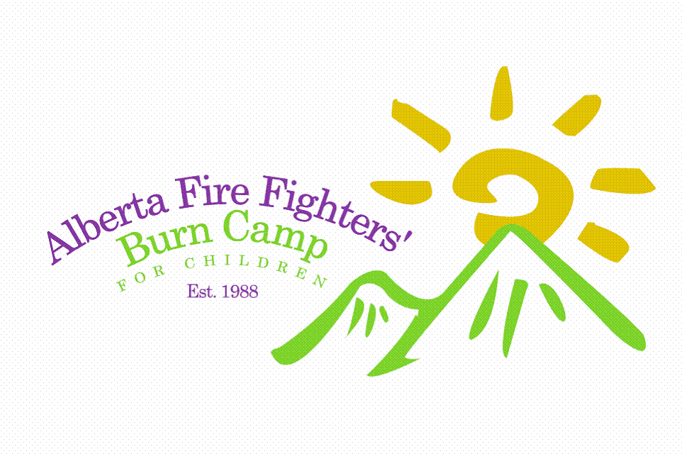

Optional Photo, Film and Video Consent:

**Please strike through if no photos of your camper are to be taken.**

The Alberta Fire Fighters’ Burn Camp nonprofit organizations and relies heavily upon the donations from the public and business sector for its operation. If it were not for donations, they could not operate.

Film and video presentations are often made to build awareness and to raise funds, and photo displays are used at various fairs and events to promote awareness of Burn Camp and The Burn Treatment Society and to recruit volunteers and encourage campers. The funds raised through these means, make our camp program possible.

I _____________________ (Parent/Guardian) hereby give my consent and authorization to aid The Alberta Fire Fighters’ Burn Camp in conjunction with The Fire Fighter’s Burn Treatment Society by having pictures or video footage of ____________________________ (participant) taken during the Summer of 2012 to be used for a period of up to 10 years for advertising purposes for The Alberta Fire Fighters’ Burn Camp and Fire Fighter’s Burn Treatment Society knowing that no identifying names or addresses will be given.

Executed this_____ day of______ , 201_, at__________, Alberta.

__________________________________ _______________________________________
Parent or Guardian Signature Witness Signature

____________________________________ ______________________________________
Printed Name of Parent or Guardian Printed Name of Witness

